Report on Training of the Trainers (TOT) on IRHR (Internet Rights Human Rights) Curriculum for Grassroots Beneficiaries
  - Pilot Training

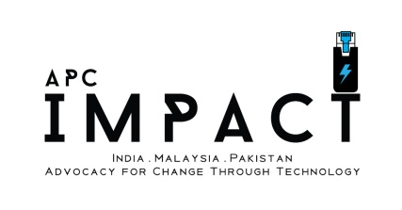

Date: June 20th, 2015

Venue: DEF Office, New Delhi

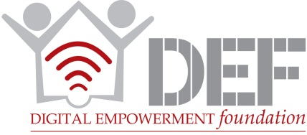
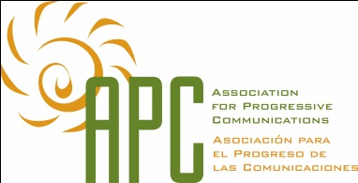

Background

New Delhi, India – A team of 6 potential trainers underwent the pilot training of the IRHR Curriculum for Grassroots Beneficiaries. This curriculum is a specially designed and lighter version of the full IRHR Curriculum created by APC. It is tailored towards the needs and requirements of the rural and peri-urban beneficiaries in India.
Niki Shah, Rajat Kumar, Pawas Suren and Rishi Jain of the DEF Research Team designed this curriculum.
The modules of the curriculum were created using the principles of Participatory Rural Assessment/Appraisal (PRA) and Participatory Learning & Action (PLA) with help from Ms. Saba Pandey of the DEF CIRC Team.
The intention of conducting a pilot training was to assess the quality, delivery and relevance of the curriculum content. This is the first step in the finalising the curriculum that would be delivered to the beneficiaries. A workflow of the curriculum development is given below.

Figure 1: Curriculum Development Flow
Feedback gathered from the participants is in the process of being incorporated into the curriculum to create the second version. A copy of the feedback form can be found in Annexure 1.

Session Details

Details of participants and trainers
The training began with an introduction of the participants and trainers. The list of participants and trainers is given below:
S. No | Name | Age & Gender | Designation
1 | Jatin Babbar | 27, Male | Project Coordinator – INDUS
2 | Bijo P. Abraham | 32, Male | Research Fellow
3 | Rishi Jain | 20, Male | Research Intern
4 | Mubeen Siddiqui | 24, Male | Picture & Content Editor
5 | A. Vahid | 30, Male | Project Officer
6 | Shah Alam | 20, Male | Programme Coordinator

The participants were drawn from members of the DEF staff that have considerable experience in fieldwork and/or were able to provide substantive and helpful comments on the curriculum based on their understanding of the subject matter and its translation into real world scenarios.
The details of the trainers are given below:
S. No | Name | Age & Gender | Designation
1 | Niki A. Shah | 34, Male | Project Officer – APC IMPACT
2 | Rajat Kumar | 28, Male | Trainer – APC IMPACT
3 | Pawas Suren | 36 Male | Trainer – APC IMPACT

Session 1 – Deconstructing Internet Rights and Human Rights
The session began with deconstructing the concepts of Internet Rights and Human Rights by enquiring about the nature of the Internet and engaging in a word association exercise viz. the purposes, benefits and positive/negative impacts of the internet.
Next, the construct of Human Rights was broken down into a discussion of the concept association that the words “Rights” brings to mind and therefore the associations with the word “Human Rights”.
Questions on what and how people communicate online and the content that they post were raised. Additionally, we inquired about the various rights and how they are exercised online in the opinion of the participants.
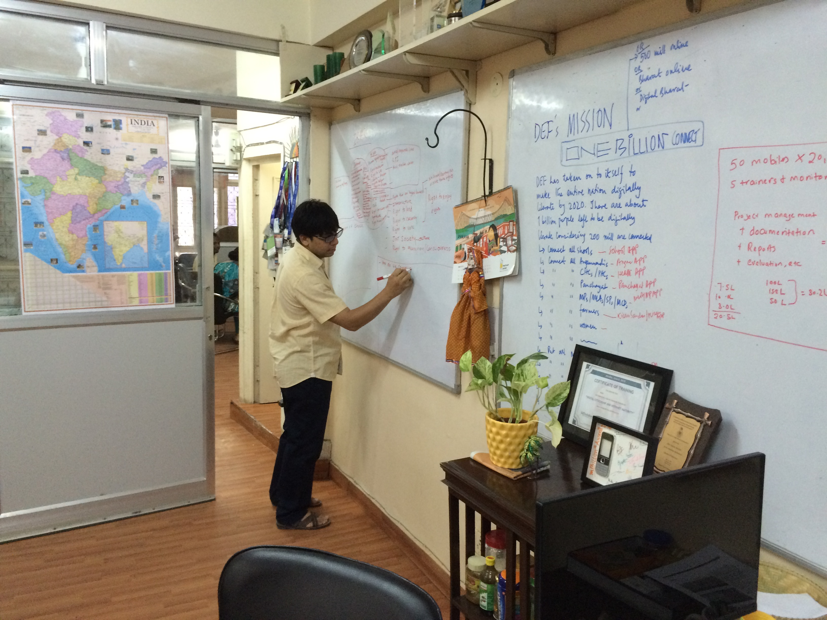

Image 1: Mapping Exercise

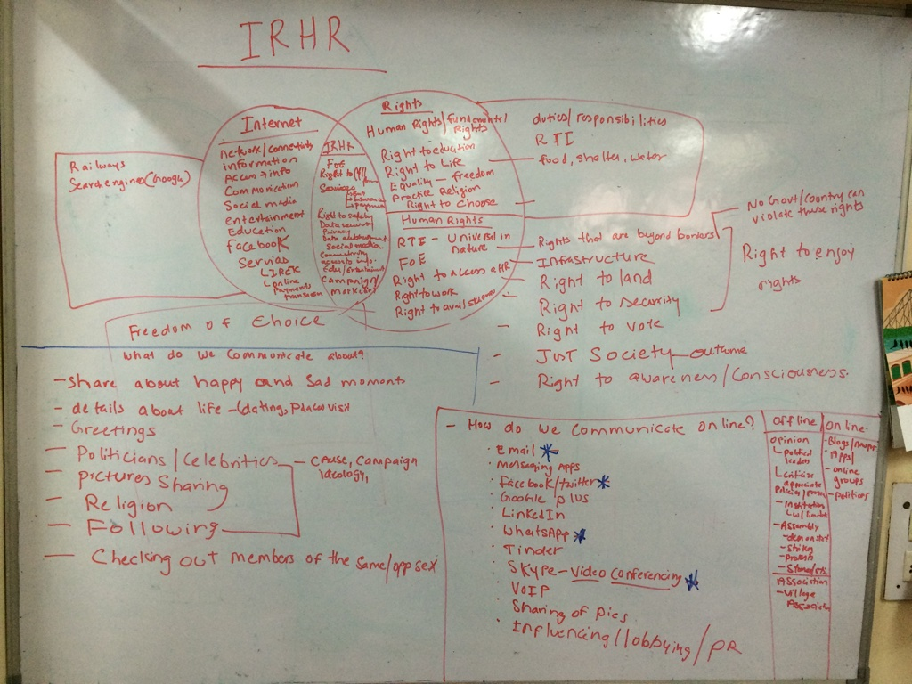
A short video on the ICICI Digital Village initiative was screened and questions were raised about internet access and its purposes at the grassroots level. We further inquired how internet access can enable Freedom of Expression in the digital space.
Image 2: Deconstructing Human Rights, Internet Rights and the Internet

Importance & Purpose of Access to ICT tools and Internet
Taking the questions on what and how people communicate online and the details of the content forward, we delved deeper into the importance and purpose of access to ICT tools and internet. We raised the following question:
- Do you access the internet?
- What tools do you use to access the internet?
- Why do you access the internet?
- What don’t you access? Why?
- What would you like to access? Why?
- Do you use social media? Why/ why not?
- Which social media platforms do you access and what do you post? Themes of the same.
This is where the field experience of the participants came to bear, with them sharing information insights from their time interacting with grassroots beneficiaries.
Email, Facebook, Whatsapp and Skype were stated as the dominant platforms for online expression in rural India. The findings of the “IMPACT Research Study: Ownership, Usability, Accessibility & Access to Rights Using ICT Tools and Applications” conducted by DEF was reflected in their responses.

Exploring Freedom of Expression
An exercise in the deconstruction of the term “Freedom of Expression” was conducted in which we asked the following questions:
- What is expression?
- What is freedom of expression?
- What is FoE offline?
- What is FoE online?
We proceeded to introducing the Right to Freedom of Expression as laid down in the Constitution of India and international human rights mechanisms. The limitations to FoE as stated in Article 19(2) of the Indian Constitution were introduced and explored deeply, with much debate and contradictions and with no consensus. This reflects the reality of the debates surrounding reasonable restrictions to FoE, both; offline and online. The flow of discussions brought into focus the relevance of individual responsibility w.r.t. FoE. Within the contexts of Section 153 and 295A of the Indian Penal Code, 1860, we discussed the offences that are punishable when an individual goes against Article 19(2).
To increase the relevance to real world scenarios, we screened an interview by actor, Aamir Khan on the topic of FoE w.r.t the movie, “PK”, which was met with considerable opposition by religious groups due to a perceived offence to the Hindu religion. This was followed by a discussion on the video.

Digital Citizenship & Security
Learnings derived from the discussion on the video shown in the previous session were carried forward to introduce the concepts of being a responsible citizen online and protecting oneself. In this session, we focused on the following questions:
- What is a good citizen?
- What is a good digital citizen?
- What is role of individual responsibility?
We also discussed about the basics of protecting oneself online from phishing, identity theft, email scams, trolls etc.
We also raised a discussion on tolerance and acceptance of differing viewpoints and its applicability online.
This session ended with the screening of a video on the “A to Z of Freedom Of Expression by #BindaasRepublic”.
We then opened the floor for any further discussion and for the filling of the feedback form. The overall response from the participants was positive across the board in terms of the content, delivery and exercises. We received some unique feedback and comments that are mentioned below:
- “Since there is limited internet access in rural areas, the concept of training on internet rights is relatively moot.”
- “The training curriculum should answer these basic questions:
  - What is the relevance of IRHR to daily life?
  - How does it improve standard of living?
  - Why should IRHR become a basic right when other rights such as right food, education, water, health etc. are not being delivered?
  - What’s in it for me?”

